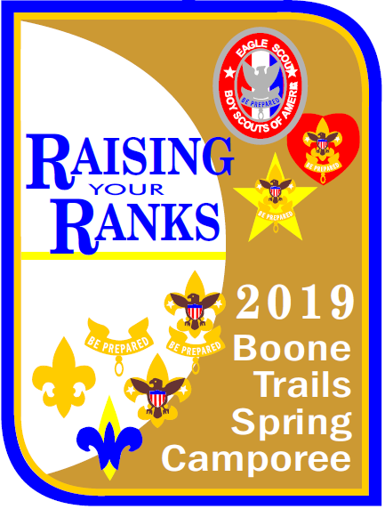
2019 Spring Camporee
March 29 - 31
Camp Vandeventer

“Raising Your Ranks”

FIRST DRAFT EARLY MANUAL
A final manual will be posted before the Camporee with updated information.
This manual is provided for troops to register and begin planning for the event.
Table of Contents
Welcome to Camp 3
Camporee Event Overview 4
Camporee Manual 4
Camporee Staff 4
Registration 5
Camporee Lunch 5
Camp Guidelines 6
Camp Etiquette 7
Activities 7
Competitions 8
Older Scout Program 9
Leader Training 9
Boone Trails Items 9
Scouts BSA Merit Badges 10
Webelos 11
STEM NOVA Awards 11
Schedule 12
Activity Locations 13
Event Map 14

Welcome to Camp
Welcome to the Boone Trails 2019 Spring Camporee, “Raising Your Ranks”. We will have a lot of fun activities for both Scouts BSA and Webelos to have fun while providing rank advancement opportunities.
When arriving at camp, participants are asked to stop at the checkpoint to receive updated information from staff. Please park in the designated parking areas and follow the traffic guidelines. Please be courteous and ask your troop leaders and guests to park in front of your troop campsite so that other troops have room to drop off and park their support vehicles.
Upon arrival, please send your Scoutmaster and SPL to Headquarters (HQ) to check in along with a copy of your registration list and health forms. Check-in will begin at 5:30 PM and end at 9:00 PM Friday night. Headquarters will be at the Dining Hall.
There will be an opening leaders’ meeting on Friday night. During this meeting, staff will provide updates regarding all changes to this manual including plans for possible weather during the event. We will also review camp safety and emergency procedures including both weather and medical emergencies. Please be sure to send your Scoutmaster and SPL to the opening meeting for these important updates.
At checkout please send your Scoutmaster and SPL to HQ when your campsite is clean including all gear stowed away and campsite inspected for trash. Staff will inspect your campsite and then release your troop and event package when completed.
Our Boone Trails camporee is youth led. During the camp, please listen to and follow the directions provided by the youth staff. If you have any question or comments, please don’t hesitate to contact staff or visit HQ. We are here to make sure that your troop has a great time and looks forward to our next District camping event. We welcome and appreciate your feedback along with suggestions for the future.
SENIOR STAFF FOR HIS EVENT:
- CAMPMASTER: Christopher Doering chris@learnovator.com
- ASST. CAMPMASTER: Clayton Widtfeldt
- ACTIVITIY: Friederich Owen
- LOGISTICS: Josh Kroc
- ADULT ADVISOR: Rick Hammond
- CAMPING CHAIR: Mike Venegoni venegoni1910@gmail.com

Camporee Event Overview
The Boone Trails 2019 Spring Camporee will be held at Camp Vandeventer in Waterloo, Illinois from March 29 - 31. We have access to the entire camp for our Camporee and we are planning to get the most out of the camp facilities including the camping areas, lodges, rappelling, and natural areas. Scouts BSA and Webelos activities include rank advancement opportunities, merit badges and many unique competitions including an Adventure Race. In addition, registration includes a lunch for all participants catered by the OFP (if registered by March 24) and a unique Boone Trails collectable.

Camporee Manual
Planning for the camporee takes months and goes right up to opening night as staff adjusts for the availability of equipment, resources, counselors, and the weather. In order to publish information as soon as possible, a first draft manual is provided for troop planning. A final draft manual will be published about a week before the camporee and updates will be announced at the opening leaders’ meeting. Troop feedback based upon the first draft manual is appreciated for review during the planning process.

Camporee Staff
Our District camporee is youth led. The Campmaster, senior staff, and many youth staff volunteers from troops around our District are excited about the event and working hard to ensure that every participant has a good time.
We welcome Scouts and adults to join staff and help plan events that your troop wants to attend. Meetings are generally held on Wednesday night at the Spencer Road Library from 7:00 to 8:30 PM. Scouts are asked to contact the Campmaster for meeting dates.
Tentative meeting dates are as follows:

- February 6
- February 13
- February 20
- February 27
- March 6
- March 13
- March 20
- March 27

Registration
The event fee for this camporee will be $15 until online registration closes on March 26. If you do not register by this date but still wish to attend you may pay a fee of $20 at the event. The fee includes the event patch, program materials, lunch on Saturday, and a unique Boone Trails collectable. Please note that Saturday lunch is not guaranteed for registrations after March 24. Event registration can be found on the Boone Trails District camping webpage.
Webelos are encouraged to join us at the camporee. Webelos must camp with a troop and provide their own two-deep leadership and health forms. Any Webelos den in need of a troop should contact Mike Venegoni at venegoni1910@gmail.com.
Additionally, preregistration will be available for merit badges to reserve a spot for your Scouts and so they can be prepared with any prerequisites. We’re offering very exciting badges that are sure to fill quickly, so if your Scouts are interested in a badge please register as soon as possible. Any remaining open merit badge spots after registration closes will be announced at the opening leaders’ meeting.

Camporee Lunch
A lunch on Saturday is included with registrations made before March 24. After that, we will try to accommodate but cannot guarantee lunch since the food will be ordered. The lunch menu is BBQ pulled pork sandwich, chips, cookie and bottled water. A limited amount of pulled pork without BBQ sauce will be available. Some accommodations for participants with dietary restrictions may be available by emailing venegoni1910@gmail.com.
Adults/leaders and participants are welcome to visit with the Boone Trails OFP in the Dining Hall kitchen Saturday morning to review the actual ingredient labels or ask any questions about the lunch.

Camp Guidelines
- The Scout Oath and Law will be our guide during this event.
- Absolutely NO fireworks, personal firearms, weapons, alcohol or other drugs will be permitted at the camporee. Adults that need to smoke are asked to please make sure that they are out of sight of all Scouts.
- All troops must check in their Scouts, Webelos, leaders and adults when arriving and then check out before leaving.
- Roads must remain clear for emergency vehicles. Please park in designated areas and be courteous to other troops.
- Our camporee is youth led. Please listen to and follow the youth staff directions.
- The scout uniform should be worn during the camporee. We ask that you wear your field uniform during flag ceremonies and religious services. Your activity uniform may be worn at all other times. If you are a former staffer and just attending, please refrain from wearing your staff shirt.
- Basic medical first-aid should be handled first within the troop. If there is an emergency at camp please let HQ know and follow the procedures outlined at the opening leaders’ meeting.
- BSA health forms (parts A & B) for all in camp (Webelos, Scouts, and adults) should be retained and available at the troop campsite.
- Troops must maintain the BSA guidelines for two-deep leadership and follow all other Youth Protection Training (YPT) guidelines.
- The Buddy System is required at this event and Scouts should remain within the event boundaries. No Scout should be without a buddy if outside their campsite.
- Campsite size will be assigned based upon the number of participants included in your registration. Early registration is greatly appreciated and will help staff better plan the campsite assignments and activities.
- To attend any shooting sports activity (if available), participants will be required to attend the 30-minute safety brief.
- The current camp requirements for safe fire building will be reviewed at the opening leaders’ meeting. Troops are responsible for ensuring that their campsite fires are built safely, managed and put out cold when finished.
- There will be NO fighting (verbally or physically) at this event. Any issues should be reported to staff at HQ.
- Trash dumpsters are available near the Dining Hall and the maintenance area.

Camp Etiquette
Based upon feedback from previous events, a few common camping etiquette practices help improve the enjoyment for all participants. Experienced campers are asked to share and promote these practices within their troop.
- It is generally preferable and safer to walk around another troop’s campsite rather than walk through the campsite. If you must walk through a campsite, it is courteous to first ask for permission.
- Please observe quiet hours between lights-out and reveille. Between those hours, please keep noise from conversations, music, cooking equipment, latrine doors and vehicles to a minimum so that all can get a good night’s sleep.
- Please observe surrounding campsites and the wind before building a fire. Fires built too close to another campsite risk the possibility of burning holes in tents from wind carried embers.
- Follow Leave No Trace guidelines and keep the camp clean of trash.
- Troops that arrive early should be courteous when setting camp and leave room for later arriving neighbors by not spreading out beyond their designated area.

Activities
- SCOUTS BSA RANK STATIONS: Stations or opportunities will be setup to help scouts work on requirements from Scout through First Class ranks. Scouts should bring their handbook for reference but no requirements will be signed-off by camp staff. Instead, a list of completions for each station will included in the troop packet at check-out for the scout to present to their troop leadership. Planned Activities for each rank are as follows (contingent upon sufficient staff).
  - SCOUT: 1a, 1b, 1c,1d, 1e, 1f. 2a, 2b, 2c, 2d, 3a, 3b, 4a, 4b, 5.
    - Scouts must attend a troop meeting prior to camporee for 2a, 2b, 2c and 2d
    - Scout’s patrol must be present to work on 3b
  - TENDERFOOT: 1c,2c, 3a, 3b, 3c, 4a, 4b, 4c, 5a, 5b, 5c, 6a, 6b, 8
  - 2nd CLASS: 1b, 2a, 2b, 2c, 2d, 2f, 2g, 3a, 3b, 3c, 3d, 6a, 6b, 6c, 6d, 6e, 8b, 9a, 9b
    - Scouts must bring a compass for 3a, 3b
  - 1st CLASS: 1b, 2a, 3a, 3b, 3c, 3d, 4a, 5a, 5c, 5d, 7a, 7c, 7d, 7e, 7f
    - Scouts must bring a compass for 4a
- Rappelling, Bouldering Wall, Capture the flag, blindfolded “Minefield” game
- Eagle trail nature hike and 2nd Class rank requirement 5-mile hike
- Shooting Sports: Archery, BB Guns, Wrist Rockets and Knife & Hawk throwing. Knife & Hawk throwing is only open to Scouts BSA.
- Ham Radio demonstration and Radio Fox Hunt are tentatively planned.
- Each troop SPL and ASPL are invited to a soda party on Saturday morning while Adult leaders are invited to the Coffee Klatch.
- Movie night – A movie will be shown on Friday night. Each participant should bring a chair and water bottle.
- Flag Retirement Ceremony – A flag retirement ceremony will be held before the campfire. Any flags that troops would like to include in the ceremony should be brought to HQ by Saturday at noon.
- Campfire Saturday night - Please turn in to HQ any skits, songs or run-ons that you would like to perform by 4:30 PM on Saturday.

Competitions
- Adventure Race – Teams compete to be the first to find and complete challenging obstacles around camp.
- Troop Relay Race – Troops compete in a 3/4 mile relay race around the camp
- Gaga Pit Tournament – Troops can participate in the gaga pit tournament. Each Troop can enter one team in the tournament.
- Gateway - All gateways must be scout built. Each entry must be completed by 4:15 pm on Saturday to be judged.
- Dutch Oven Cookoff- All entries must be cooked in a Dutch oven. The entry must be planned, prepared, and cooked by either Scouts or Adults and will be judged separately. Staff will judge entries on Taste, Quality, and Creativity. The entry must be brought to HQ by 3:00 pm on Saturday.

Older Scout Program
The following activities are designed for older scouts who have completed First Class or are 14 years old or older.
- Older Scout Adventure Race – Teams compete to be the first to find and complete even more challenging obstacles around camp.
- Older Scout Overnight– Older Scouts are invited to spend Saturday night at a campsite a short distance into the woods. Therefore, scouts should plan to be able to carry their overnight gear to these campsites.

Leader Training
Pressurized fuel training and SM/ASM Leader Specific Training (indoor session only) will be offered during the camporee.

Boone Trails Items
There will be unique Boone Trails items for sale at HQ including Boone Trails event patches. Please stop by HQ to see what is available.

Scouts BSA Merit Badges
Merit badge slots can be reserved online along with camporee registration. Remaining slots will be available for reservation during the opening leader’s meeting on Friday night. Scouts are asked to bring a blue merit badge card to the merit badge and complete any prerequisites as noted below.

First Aid Merit Badge

Prerequisites: Bring a personal first aid kit from home

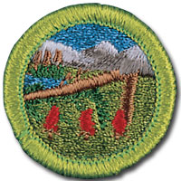 | Wilderness Survival Merit Badge  Prerequisites:  • # 5. Put together a personal survival kit and explain how each item in it could be useful.  • # 11. Show that you know the proper clothing to wear while in the outdoors during extremely hot and cold weather and during wet conditions (each scout should come dressed appropriately for the weather and be prepared to discuss).  • Bring written answers to 1a, 1b, 4, 9 and 12.  Scouts should have completed 2st Class and be experienced campers.
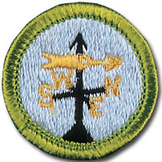 | Weather Merit Badge  Prerequisites: TBA

Webelos
The following Webelos adventures are planned. Webelos can sign up to participate in the class at the opening leader’s meeting and during the event on Saturday.
First Responder Sports
(Morning Only)

STEM NOVA Awards
A Cub Scout STEM Nova will be offered. Sign-up is not necessary but scouts must be present when the session begins to complete the Nova. Two sessions will be offered. The first session runs from 8:15 to 10:15 AM and the second runs from 1:00 to 3:00 PM.
Cub Scout Nova: Nova Wild!
- Prerequisites: Watch an episode of a show or read (about one hour total) about wildlife, endangered species, invasive species, food chains, biodiversity, ecosystems, or wildlife habitats.
A list of Nova completions will be included in the troop/pack packet at check-out for unit leadership to complete the Nova award.
Supernova Mentors will also be on site for Scouts BSA or Webelos that would like to work on a Supernova.

Schedule
FRIDAY
5:30 pm Check-in opens at HQ
9:00 pm Check-in closes
Opening Leaders’ Meeting starts
Movie night starts (bring a chair)
11:00 pm Lights out

SATURDAY
6:00 am Reveille
7:30 am Flag ceremony at HQ and morning announcements
8:15 am Activities open and Merit Badges start
Webelos Nova morning session starts
9:00 am Coffee Klatch by OFP (Adults/Leaders)
Soda Party (Troop SPL / ASPL)
11:45 am Activities close
12:00 pm Lunch at Dining Hall field
1:00 pm Activities open and all Competitions begin
Webelos Nova afternoon session starts
3:00 pm Bring Dutch Oven creation to HQ to be judged
4:00 pm Activities close
4:30 pm All Campfire sheets are to be turned in to HQ
Gateway judging starts
5:00 pm Dinner at campsites
6:15 pm Flag ceremony at HQ
7:00 pm Religious Services start
8:00 pm Religious Services end
8:15 pm Flag Retirement and Campfire starts
10:00 pm Campfire ends
11:00 pm Lights Out

SUNDAY
6:00 am Reveille
7:30 am Closing Flag Ceremony at HQ
8:00 am Check-out begins at HQ
11:00 am Camp Closed

Activity Locations
FRIDAY
Check-in HQ at Dining Hall
Movie Night Dining Hall
Opening Leaders’ Meeting Council Ring

SATURDAY
Opening Flag Ceremony HQ at Dining Hall
Coffee Klatch Dining Hall
Lunch by OFP Dining Hall
Adult Leader Training TBA

First Aid MB Dining Hall
Wilderness Survival MB Class at Rotary Pavilion. Overnight at Bobcat.
Weather MB TBA

SCOUT Rank Req. TBA
TENDERFOOT Rank Req. TBA
2nd Class Rank Req. TBA
1st Class Rank Req. TBA
Hike Starting Point TBA

Webelos Adventures TBA
Webelos Nova TBA

Race starting lines TBA
Gaga pit competition Dining Hall field
Bouldering Wall Behind Office Building
Rappelling Along road north of Chapel
Knife & Hawk throwing Dining Hall field
BB Gun Dining Hall field
Archery Dining Hall field
Wrist Rockets Dining Hall field
Capture the flag Dining Hall field

Religious Services Catholic Services in Dining Hall
Protestant Services in Chapel
Scouts Own Service at Council Ring

SUNDAY
Closing Flag Ceremony HQ at Dining Hall
Check-Out HQ at Dining Hall

Event Map
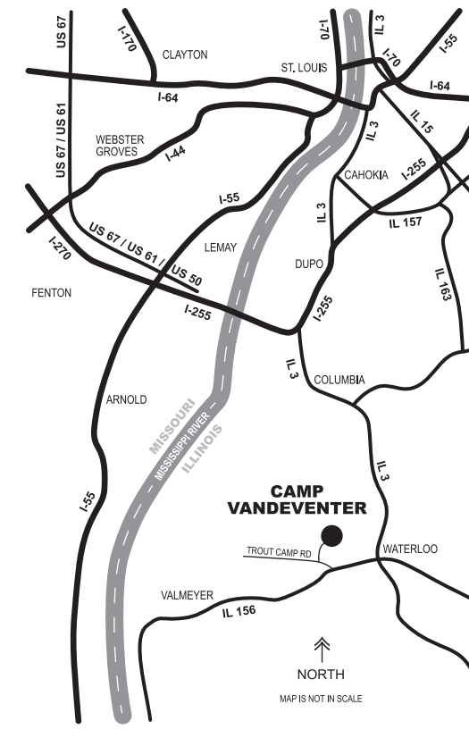
Camp Vandeventer is about 50 miles from St. Charles at 3463 Trout Camp Rd, Waterloo, Illinois 62298. Entrance to the camp is on Trout Camp Road from Illinois Highway 156.
We have access to the entire camp for our camporee. Camping will be on Flag Hill, Ziebold Range Field, Bear, Pinewood, Wolf, Bobcat and possibly Webelos campsites.
Events and the schedule have been planned to get the most out of the camp facilities while limiting required travel as much as possible. Nevertheless, participants are advised to prepare for some additional walking at this camporee similar to a summer camp.

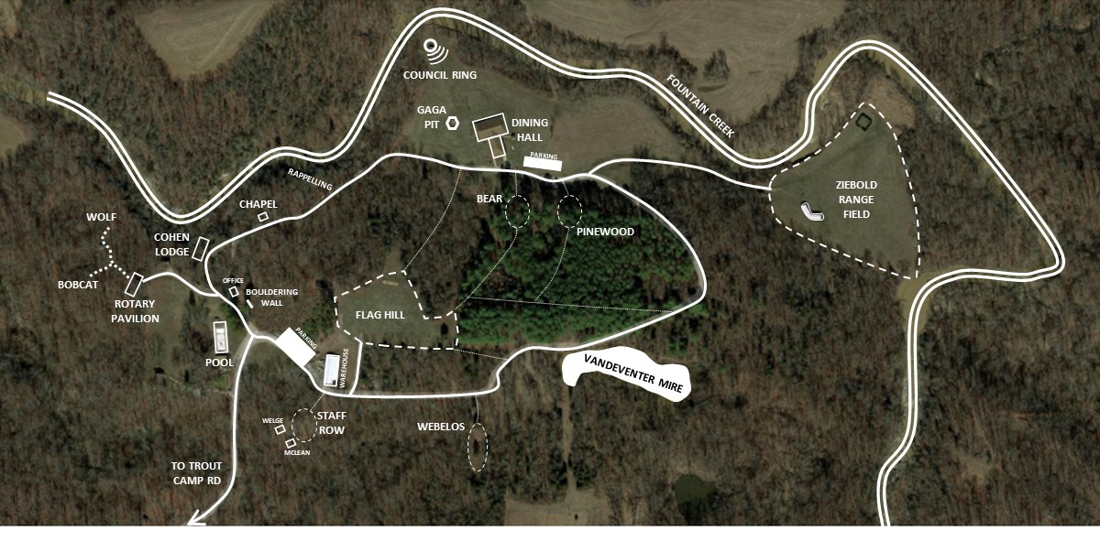

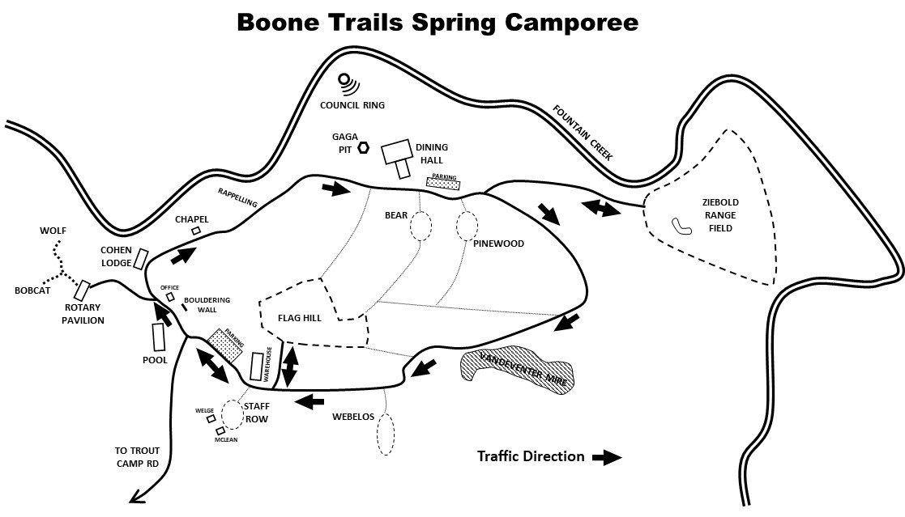

Parking and Friday Night Traffic Plan
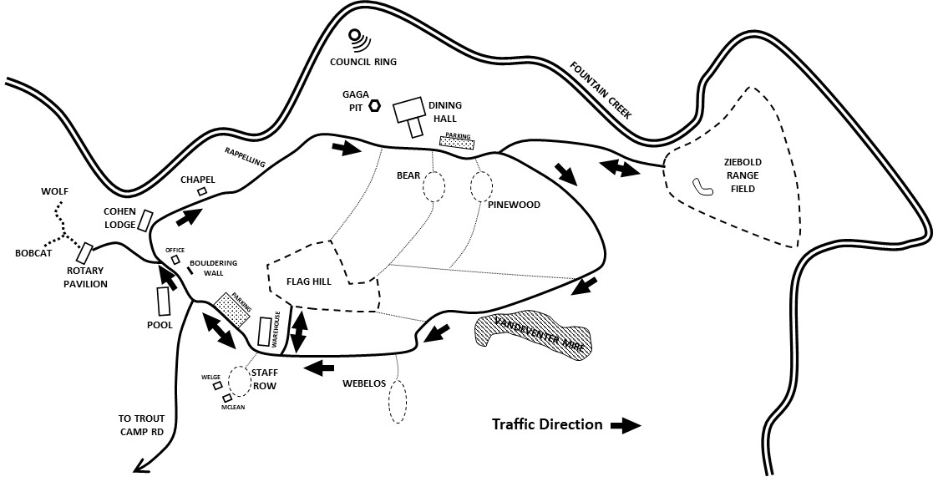
On Friday evening, staff will be located to greet you at a checkpoint just before the pool. All traffic will be clockwise except for those camping on Flag Hill. The entrance to Flag Hill is behind the maintenance area and is angled for approach to the right from the camp entrance (counterclockwise).
The parking lot in the front of camp is small and will be reserved. All parking for the event will be at the campsites or along the roadside in designated areas where the road is wide enough for parking. All cars parked on Flag Hill or Ziebold Range should plan to remain in place during the camporee.
All campers are encouraged to combine camping gear into their troop trailer and/or a support vehicle. So that we can maximize the area to camp, troops should plan to limit campsite parking as much as possible.

