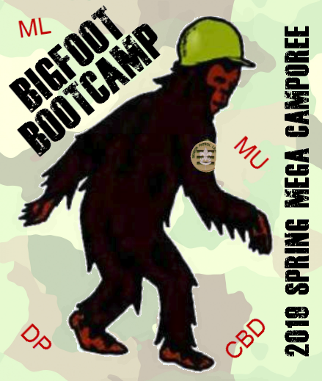

Leaders Guide
Bigfoot Boot Camp

May 3-5, 2019
Phillippo Scout Camp

2019 Spring Mega Camporee
Metro Lakes, Dan Patch
Chief Black Dog, Mustang

Registration: Registration is open to Scouts BSA and Venture Scouts.
https://www.scoutingevent.com/250-megaspringcamp2019

Fees:
Youth | $14.00
Adult | $9.00
Staff - Saturday Day Only | $0.00
Staff - Weekend Camping | $5.00

Check-In:
6:00-8:00pm – arrive, check in, set-up camp at assigned location

Leadership:
Troops must follow youth protection and 2 deep leadership guidelines for camping.
Part A & B Health forms must be kept with troop leader and be available at registration.

Food:
No meals will be provided by the camp
Lunch on Saturday will be provided for anyone staffing one of the stations
Units are responsible for cooking and cleanup of all meals for their members.
This is a pack-in/pack-out Leave No Trace camporee. All trash must be removed by the unit.

Equipment:
Boots and gloves for phase one of the reforestation service project: buckthorn removal
Sunscreen and Bug Spray; water bottle

Campfire Skits:
Each unit or patrol to do a skit or song appropriate for one of the Leave No Trace/Outdoor Ethics/Tread Lightly principles

Awards:
Units can earn the Big Foot Award by earning points at stations; best Big Foot camouflage costume, best Forester(service project participant) and following the Leave No Trace principles throughout the Camporee.

Schedule:
FRIDAY
6:00-9:00 – arrive, check-in at Radisson Shelter - upper camp, set up camp at assigned Campsites
9:00 –Cracker barrel for SPLs and Unit Leaders at Radisson Shelter
11:00 –Lights Out

SATURDAY
6:30-7:45 – Breakfast in camp
8:00-8:20 –Flags and Opening at Field
8:30-11:30 –Stations
11:30-12:45 – Lunch and troop time in camp
1:00-5:00 – Stations
5:00-6:55 – Dinner and troop time in camp
7:00 – Bigfoot Camp Games
8:30 – Campfire at Main camp Fire Ring –All units expected to provide a skit or song
11:00 –Lights Out

SUNDAY
9:00-9:20 – Scout’s Own Service at Friendship Point
9:30-11:00 – Site inspection and Check-out
11:00 – Camp Closed

Event Description – Learn how Big Foot uses Leave No Trace as your patrol solves puzzles to win the Big Foot Boot!
Patrols form teams of 8 – 10 scouts. Start by showing PL you are prepared for a hike
Teams complete 3 stations in the morning and 4 stations in the afternoon, including the service station.
Teams win points for solving problems, team work, and trying challenges.
Teams loose points if adults are too helpful.

Advancement Requirements covered by stations:
A scout doing all the stations will be prepared to complete these requirements

Awards:
Outdoor Ethics Awareness Award
https://www.scouting.org/outdoor-programs/outdoor-ethics/awards/scouts-bsa/
- Send list of youth who have completed requirements 1-4 of the Outdoor Ethics Award to hlgroven@gmail.com by April 19th
- Youth at camporee will complete requirement 5 of the award
- Youth completing all requirements will receive a certificate at camporee

Advancement:

- Scout Requirements
1.e. Repeat from memory the Outdoor Code. In your own words explain what the Outdoor Code means to you.

- Tender foot Requirements
  - CAMPING AND OUTDOOR ETHICS
1.C. Tell how you practiced the Outdoor Code on a campout or outing.
  - COOKING
2. B. While on a campout, demonstrate the appropriate method of safely cleaning items used to prepare, serve, and eat a meal.

- Second Class Requirements

Camping and Outdoor Ethics
1b. Explain the seven principles of Leave No Trace and tell how you practiced them on a campout or outing. This outing must be different from the one used for "Tenderfoot requirement 1c".

1c. On one of these campouts, select a location for your patrol site and recommend it to your patrol leader, senior patrol leader, or troop guide. Explain what factors you should consider when choosing a patrol site and where to pitch a tent.

Cooking and Tools
2a. Explain when it is appropriate to use a fire for cooking or other purposes and when it would not be appropriate to do so.

2c. At an approved outdoor location and time, use the tinder, kindling, and fuel wood from "Second Class requirement 2b" to demonstrate how to build a fire. Unless prohibited by local fire restrictions, light the fire. After allowing the flames to burn safely for at least two minutes, safely extinguish the flames with minimal impact to the fire site.
- 1st Class Requirements
  - Explain each of the principles of TreadLightly! and tell how you practiced them on a campout or outing. This outing must be different from the one used for tenderfoot requirement 1c or Second Class requirement 1.b".

- Merit Badges:

  - Hiking:
2. Explain and, where possible, show the points of good hiking practices including proper outdoor ethics, hiking safety in the daytime and at night, courtesy to others.
  - Cooking:
g. Explain to your counselor how you cleaned the equipment, utensils, and the cooking site thoroughly after each meal. Explain how you properly disposed of dishwater and of all garbage.

h. Discuss how you followed the Outdoor Code and no-trace principles when preparing your meals.

  - Camping
2. Learn the Leave No Trace principles and the Outdoor Code and explain what they mean. Write a personal and group plan for implementing these principles on your next outing.

