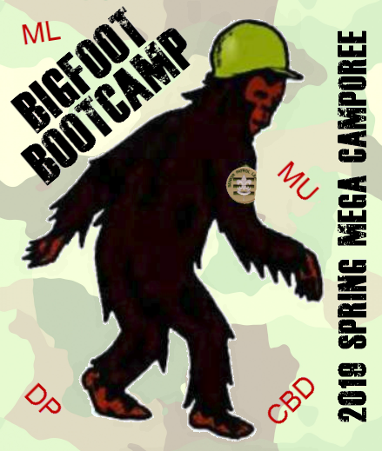

Bigfoot Boot Camp

May 3-5, 2019
Phillippo Scout Camp

2019 Spring Mega Camporee
Metro Lakes, Dan Patch
Chief Black Dog, Mustang

Learn how Big Foot uses Leave No Trace as your patrol solves puzzles to win the Big Foot Boot
Registration opens soon
https://www.scoutingevent.com/250-megaspringcamp2019

